# 🔄 Chapter 7 — AgilePM Process Framework and the Project Lifecycle

## **7.1 Introduction**

AgilePM v3 defines a **structured process framework** that balances **agility, governance, and business alignment**. Unlike traditional project methodologies, AgilePM combines:

* **Iterative delivery** of increments through timeboxes.
* **Governance checkpoints** to ensure compliance and risk management.
* **Collaboration across stakeholders**, including business, technical teams, and QA.
* **Integration with Scrum** to provide flexibility at the team level.

The framework is designed to address common project challenges: Misalignment, delays, risks, and quality issues.

AgilePM divides the project lifecycle into **six distinct phases** (though Feasibility may be combined with Pre-Project in smaller initiatives):

1. **Pre-Project** – Evaluate feasibility and business justification.
2. **Feasibility** – Assess viability and risk.
3. **Foundations** – Define priorities, approach, and initial plans.
4. **Evolutionary Development** – Iterative delivery of working increments.
5. **Deployment** – Transition deliverables to production.
6. **Realisation** – Benefits review and lessons learned.

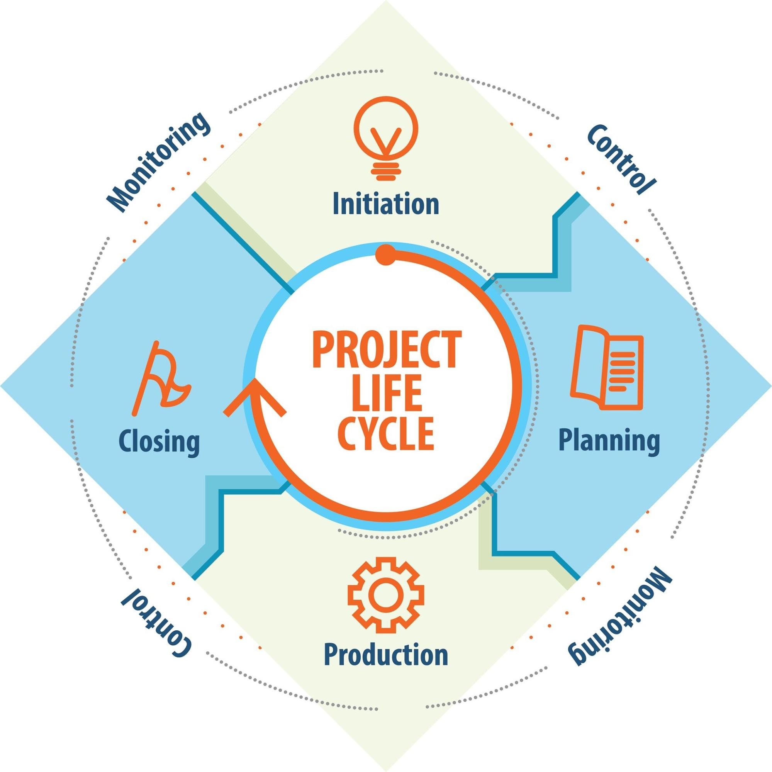Getty Images  
Explore

**Table 1 — Overview of AgilePM Lifecycle Phases**

| **Phase** | **Objective** | **Key Activities** | **Output** |
| --- | --- | --- | --- |
| **Pre-Project** | Feasibility & justification | Business Case, initial scoping | Project Brief |
| **Feasibility** | Assess viability | Risk analysis, high-level estimate | Feasibility Report |
| **Foundations** | Define approach & plan | MoSCoW prioritization, architecture | Foundations Document |
| **Evolutionary Development** | Iterative delivery | Timeboxes, Daily Stand-ups, Reviews | Timebox Deliverables |
| **Deployment** | Transition to production | Pilot deployment, UAT, training | Deployment Plan, Go-Live Approval |
| **Realisation** | Evaluate benefits | Benefits Review, Lessons Learned | Benefits Review Report |

## **7.2 Pre-Project Phase**

The Pre-Project phase ensures that the project is **viable and aligned with strategic objectives**.

**Key Activities:**

* **Define Business Justification:** Creation of the **Business Case**.
* **Appoint Key Roles:** Identify the **Sponsor** and **Project Manager**.
* **Initial Scoping:** High-level definition of what the project will deliver.

**Key Deliverable:** **Project Brief** (contains the Business Case and initial scope).

## **7.3 Feasibility Phase**

The Feasibility phase determines if the project can realistically be completed **within constraints (time, cost, quality)**.

**Key Activities:**

* **Risk Analysis:** Identify major risks and mitigation strategies.
* **High-Level Estimate:** Rough cost and effort estimation.
* **Project Approach Questionnaire (PAQ):** Assesses the suitability of the AgilePM approach.

**Key Deliverable:** **Feasibility Report** (includes PAQ summary and major risks).

**Note:** For smaller projects or highly Agile environments, the **Feasibility Phase is often merged** into the Pre-Project phase or the initial part of Foundations.

## **7.4 Foundations Phase**

This is the **most crucial planning phase** in AgilePM, where the team establishes a **firm foundation** before iterative development begins.

**Key Activities:**

* **Solution Definition:** Define high-level requirements and architecture (Technical Coordinator).
* **MoSCoW Prioritization:** Prioritize all **Must Haves** and establish clear boundaries.
* **Initial Planning:** Create the **Development Plan** (release schedule and iteration sizing).
* **Refined Roles:** Finalize the team and appoint the **Business Ambassador**.

**Key Deliverable:** **Foundations Document** (containing the architecture, prioritized requirements, Development Plan, and Risk Register).

## **7.5 Evolutionary Development Phase**

The core of AgilePM, where **working increments are delivered** through a series of **Timeboxes** (Sprints in Scrum integration).

**Key Activities:**

* **Timebox Planning:** Detailed planning of tasks for the current timebox.
* **Develop and Test:** Iterative coding and testing, ensuring **quality is built in**.
* **Daily Stand-ups:** Team synchronization and impediment removal.
* **Timebox Review/Demo:** Demonstrate the increment to the Business Ambassador for acceptance.
* **Retrospective:** Continuous improvement of the team process.

**Key Deliverable:** **Timebox Deliverables** (the tested, accepted increment).

## **7.6 Deployment Phase**

This phase ensures the **successful transition** of the accepted increments into the **live operational environment**.

**Key Activities:**

* **Final Testing:** User Acceptance Testing (UAT) and regulatory compliance testing.
* **Training and Handover:** Prepare end-users and support staff.
* **Pilot Deployment:** May involve a phased roll-out or beta testing.
* **Go-Live Decision:** Formal approval by the Sponsor.

**Key Deliverable:** **Deployment Plan** and **Go-Live Sign-off**.

## **7.7 Realisation Phase (Post-Project)**

This phase occurs **after deployment** and focuses on assessing whether the project achieved its intended **Business Case benefits**.

**Key Activities:**

* **Benefits Review:** Measure actual benefits against projected ROI.
* **Lessons Learned:** Conduct a comprehensive retrospective on the entire project lifecycle.
* **Project Closure:** Formal project closure and release of resources.

**Key Deliverable:** **Benefits Review Report** and **Lessons Learned Log**.

## **7.8 Governance and Checkpoints**

Governance is maintained by formal **Checkpoints** after each non-iterative phase, ensuring that the project remains **viable and controlled**.

**Table 11 — Governance Checkpoints**

| **Phase Transition** | **Checkpoint Review** | **Primary Decision-Maker** | **Critical Review Item** |
| --- | --- | --- | --- |
| Pre-Project → Feasibility | Project Brief Review | Sponsor | Business Case viability |
| Feasibility → Foundations | Feasibility Review | Sponsor / PMO | PAQ, major risks |
| Foundations → Evolutionary Development | Foundations Review | Sponsor | Architecture, MoSCoW Must Haves |
| Evolutionary Development → Deployment | Release Review | Sponsor / PM | Completed increment, UAT readiness |
| Deployment → Realisation | Deployment Sign-off | Sponsor | Go-Live approval |

## **7.9 AgilePM Lifecycle Metrics**

Metrics track progress and ensure adherence to principles.

**Table 12 — Lifecycle Metrics Example**

| **Phase** | **Metric Focus** | **Key Deliverable** | **Role Owner** | **KPI Example** | **Continuous Feedback Loop** |
| --- | --- | --- | --- | --- | --- |
| **Pre-Project** | Business justification | Project Brief | Sponsor | ROI potential | Use feedback from early stakeholders |
| **Foundations** | Planning accuracy | Foundations Document | PM / BA | MoSCoW stability | Refine requirements continuously |
| **Evolutionary Development** | Delivery & Quality | Timebox Deliverables | Team | **Velocity**, Defect Rate | Retrospectives, Daily Stand-ups |
| **Deployment** | Readiness & Acceptance | Deployment Plan, Sign-off | PM / BA | Error rate < 5% | Use feedback to adjust full deployment |
| **Realisation** | Business Impact | Benefits Report, Lessons Learned | PM / Sponsor | ROI, lessons applied | Apply lessons to next project |

## **7.10 Key Takeaways (Expanded)**

**Table 13 — Summary Table**

| **Aspect** | **Key Benefit** | **Example / Application** |
| --- | --- | --- |
| **Pre-Project** | Align project with strategic objectives | Feasibility study & approval |
| **Foundations** | Prepare delivery plan & prioritize backlog | MoSCoW prioritization |
| **Evolutionary Development** | Deliver incremental value | Iterative timeboxes with QA & demos |
| **Deployment** | Smooth transition to production | Pilot deployment, training, acceptance |
| **Realisation** | Evaluate benefits & capture lessons | ROI calculation, lessons learned workshops |
| **Scrum Integration** | Agile team delivery within governance | Sprint planning, reviews, retrospectives |
| **Metrics & Governance** | Visibility & control | Dashboards, KPI tracking, checkpoints |

Le Chapitre 7 est maintenant formaté. Voulez-vous que je continue avec le **Chapitre 8** ?